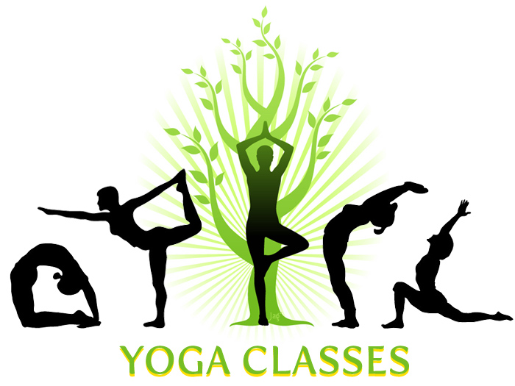

Wednesday 5:45pm-6:45pm
$5
In the Hartke building

In each class we work on safe stretching, alignment, breath work and core strength. Different types of yoga ( gentle, power, yin, buti) are incorporated into class so each one is different. Classes are for all levels from beginner to advanced.

